**Slip 1 WT**

**Slip1.html**

<html>

<frameset rows="10%,80%">

<frame name="A" src="Slip1caption.html">

<frameset cols="40%,*">

<frame name="C" src="Slip1image.html">

<frame name="D" src="Slip1website.html”>

</frameset>

</frameset>

</html>

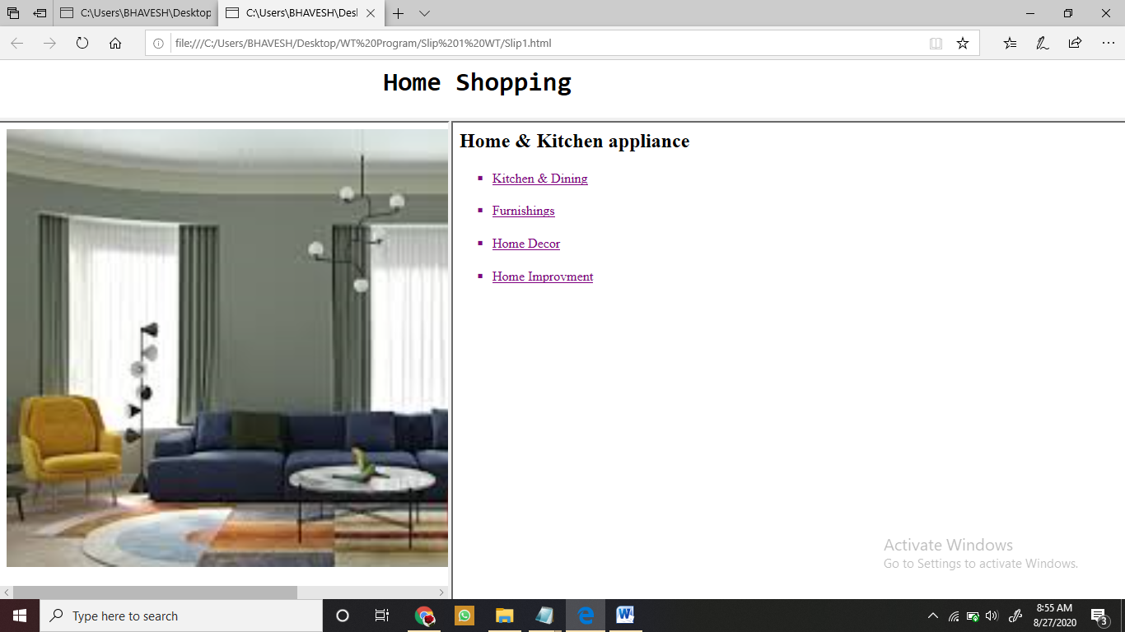

**Slip1caption.html**

<html>

<caption><h1><pre> Home Shopping</pre></h1></caption>

</html>

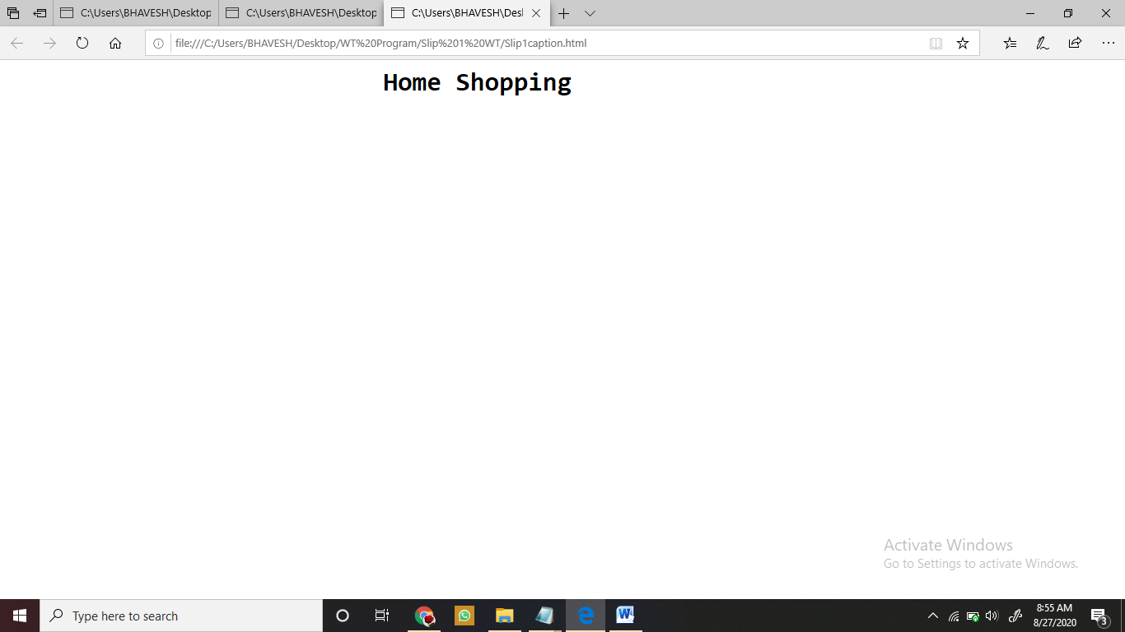

**Slip1image.html**

<html>

<body>

<img src="C:\Users\BHAVESH\Desktop\WT images\Home.jpg" width="800" heigth="800">

</body>

</html>

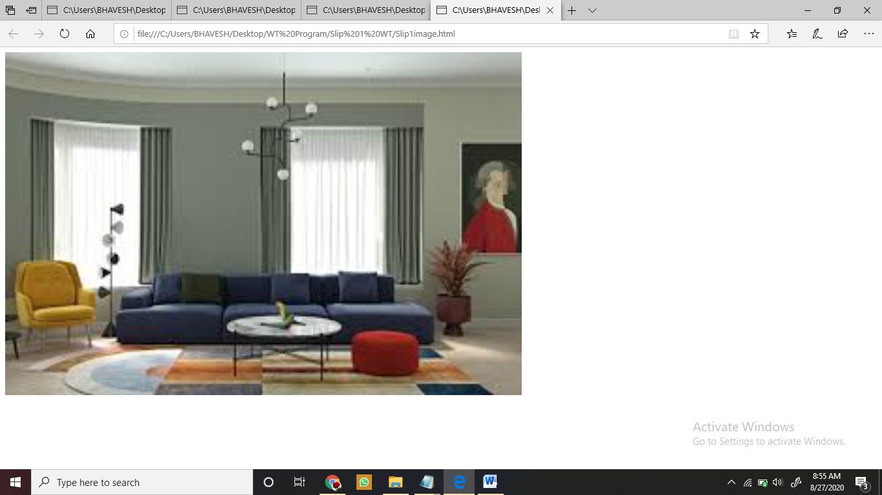

**Slip1Home.html**

<html>

<body>

<h2>Home & Kitchen appliances</h2>

<ul type="square">

<li>Kitchen & Dinning</li>

<li>Furnishing</li>

<li>Home Decor</li>

<li>Home Improvment</li>

</ul>

</html>

</body>

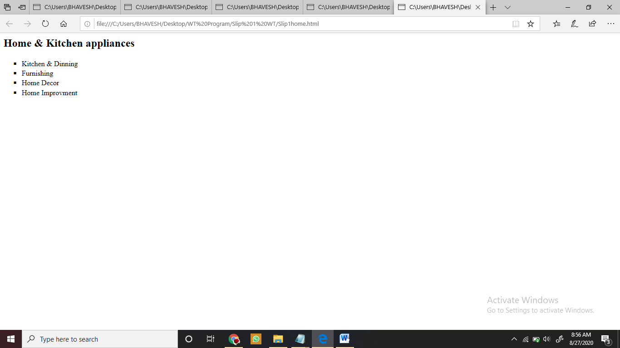

**Slip1Website.html**

<html>

<body>

<h2>Home & Kitchen appliance</h2>

<ul type="square">

<a href="Slip1Kitchen&Dining.html"><li>Kitchen & Dining</li></a>

<a href="Slip1Furnishing.html"><br><li>Furnishings</li></a>

<a href="Slip1HomeDecor.html"><br><li>Home Decor</li></a>

<a href="Slip1HomeImprovment.html"><br><li>Home Improvment</li></a>

</body>

</html>

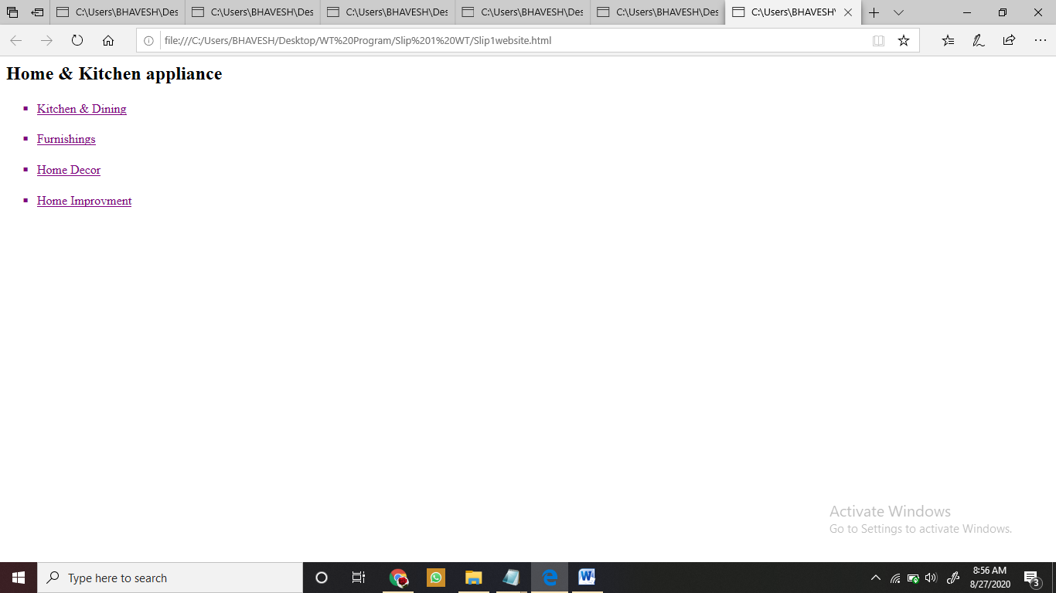

**Slip1Kitchen&Dining.html**

<html>

<body>

<a target="_New" > </a>

<h1> Kitchen & Dining</h1>

<ol type="i">

<li> Cookware</li>

<li> Kitchenware </li>

<li> Bakeware </li>

<li> Serveware</li>

</ol>

</body>

</html>

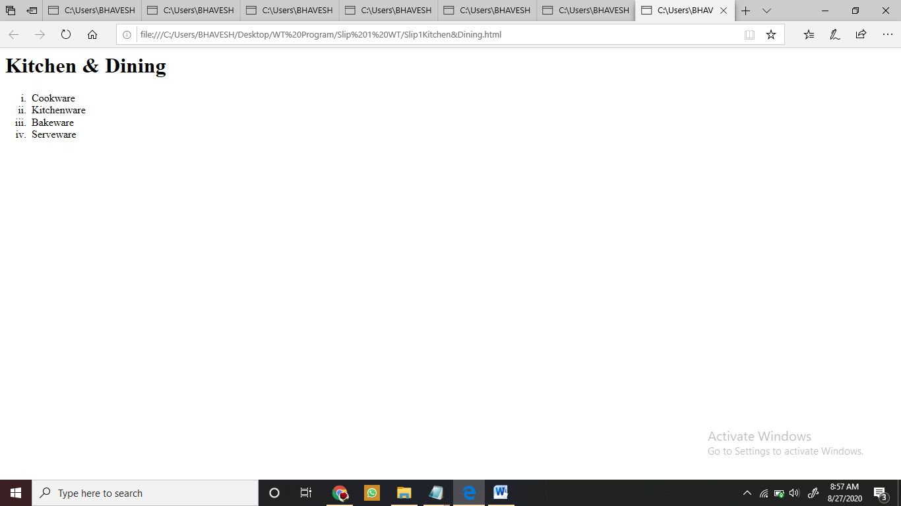

**Slip1Furnishings.html**

<html>

<a target="_New" > </a>

<h1> Furnishing</h1>

<ol type="i">

<li> Mattresses</li>

<li> Curtains </li>

<li> Mats </li>

<li> Pillows & Covers</li>

</ol>

</html>

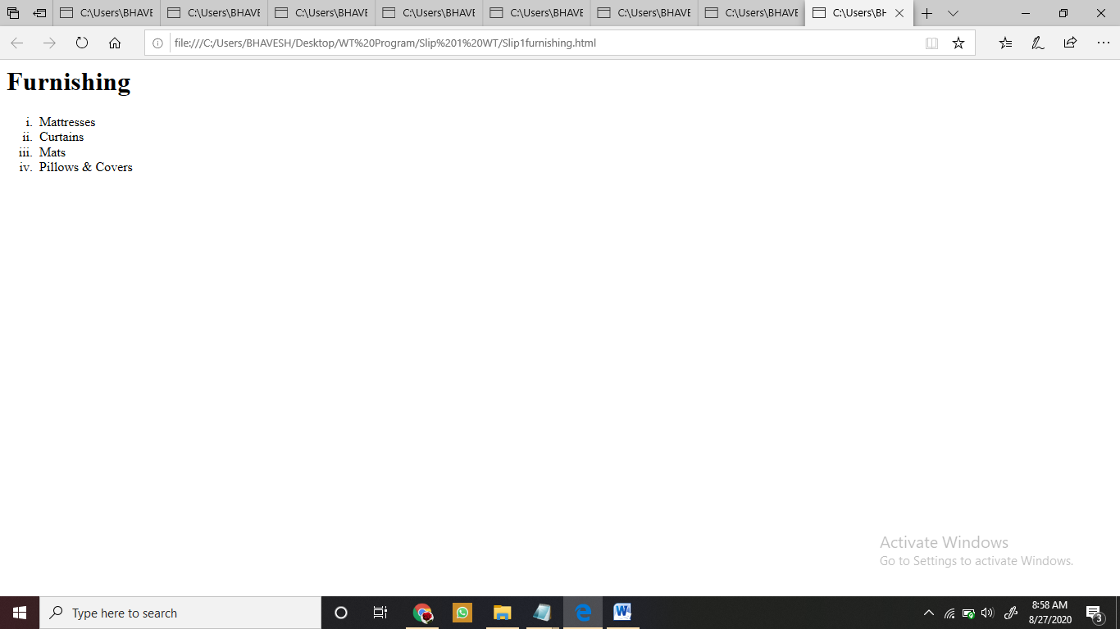

**Slip1HomeDecor.html**

<html>

<a target="_blank" > </a>

<h1> Home Decor</h1>

<ol type="i">

<li> Small Fountains</li>

<li> Clocks </li>

<li> Table Decor </li>

<li> Lamps & Lighting</li>

</ol>

</html>

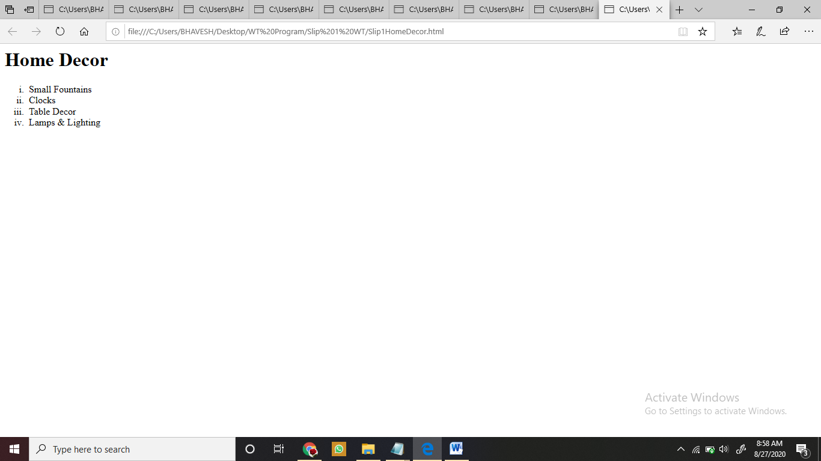

**Slip1HomeImprovement.html**

<html>

<a target="_blank" > </a>

<h1> Home Improvment</h1>

<ol type="i">

<li> Lighting</li>

<li> Appliances </li>

<li> Tile</li>

<li> Paint & Wall Covrings</li>

</ol>

</html>

